Name:-Ganesh Natarajan slot :-c
Reg.no:-192412332 ECA3102 - NANO ELECTRONICS
EXP.NO:1
Simulation of Density of States of Quantum Well Structure with Various Nanometer Thickness.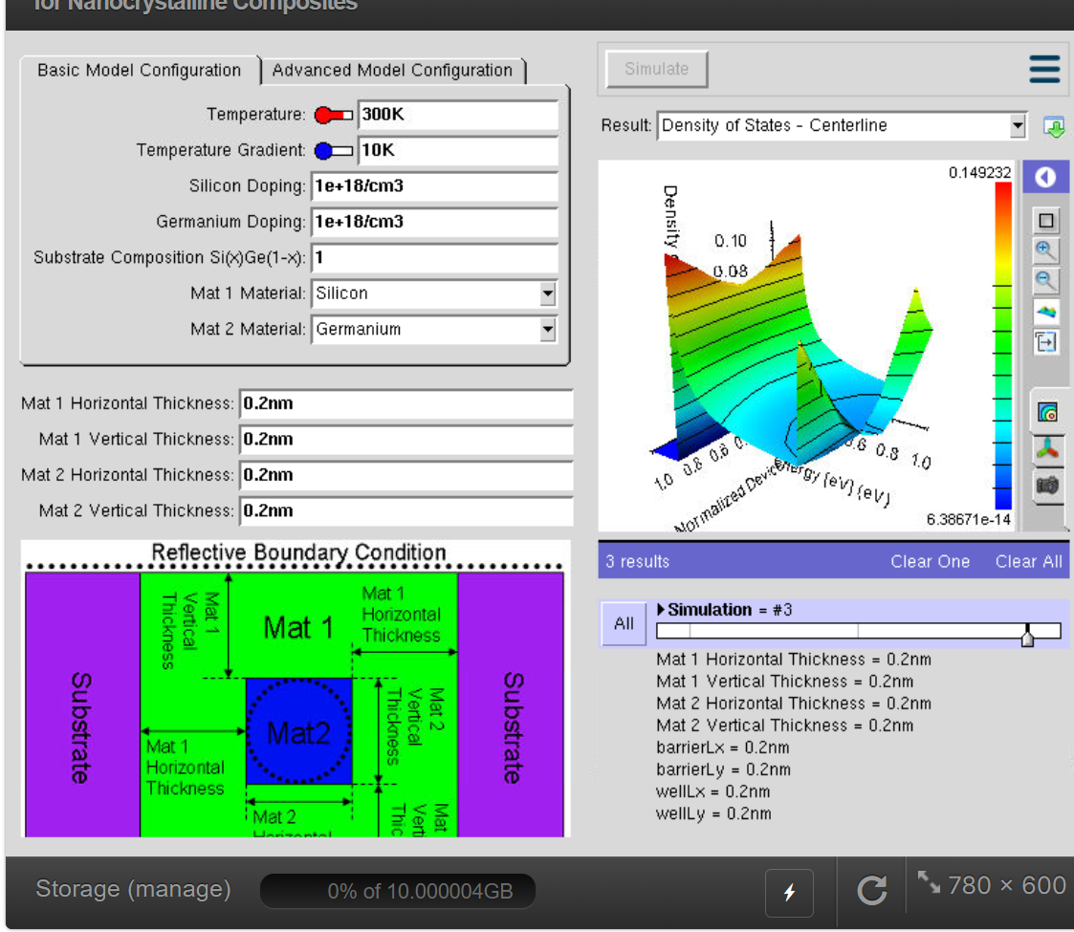
Figure 1
Density of States (DOS) Distribution Along the Centerline of a Si/Ge Nanocrystalline Composite (Thickness = 0.2 nm)

Interpretation
- The DOS plot shows distinct peaks at specific energy levels, indicating the formation of quantized energy states due to strong quantum confinement in the 0.2 nm nanostructure.
- The high DOS regions (red/yellow) represent a greater number of available electronic states, while the low DOS regions (blue) indicate fewer available states for charge carriers.
- The simulation confirms that the ultra-thin 0.2 nm Si/Ge nanocomposite exhibits strong carrier confinement, making it suitable for high-speed and low-power nanoelectronic applications.

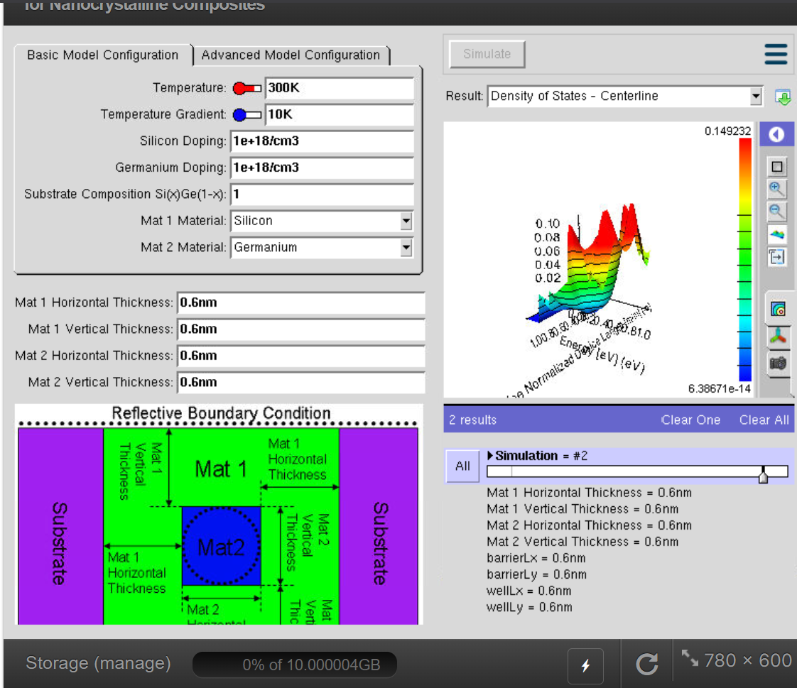
Figure 2. Density of States (DOS) Distribution Along the Centerline of a Si/Ge Nanocrystalline Composite (Thickness = 0.6 nm)

Result Interpretation
- At a thickness of 0.6 nm, the DOS plot shows multiple sharp peaks, indicating the presence of several quantized energy states due to quantum confinement.
- Compared to the 0.2 nm structure, the DOS is distributed over a wider energy range, showing that increasing the material thickness modifies the electronic energy levels and carrier distribution.
- The simulation confirms that the 0.6 nm Si/Ge nanocomposite provides improved carrier confinement with well-defined energy states, making it suitable for high-performance nanoelectronic device applications.

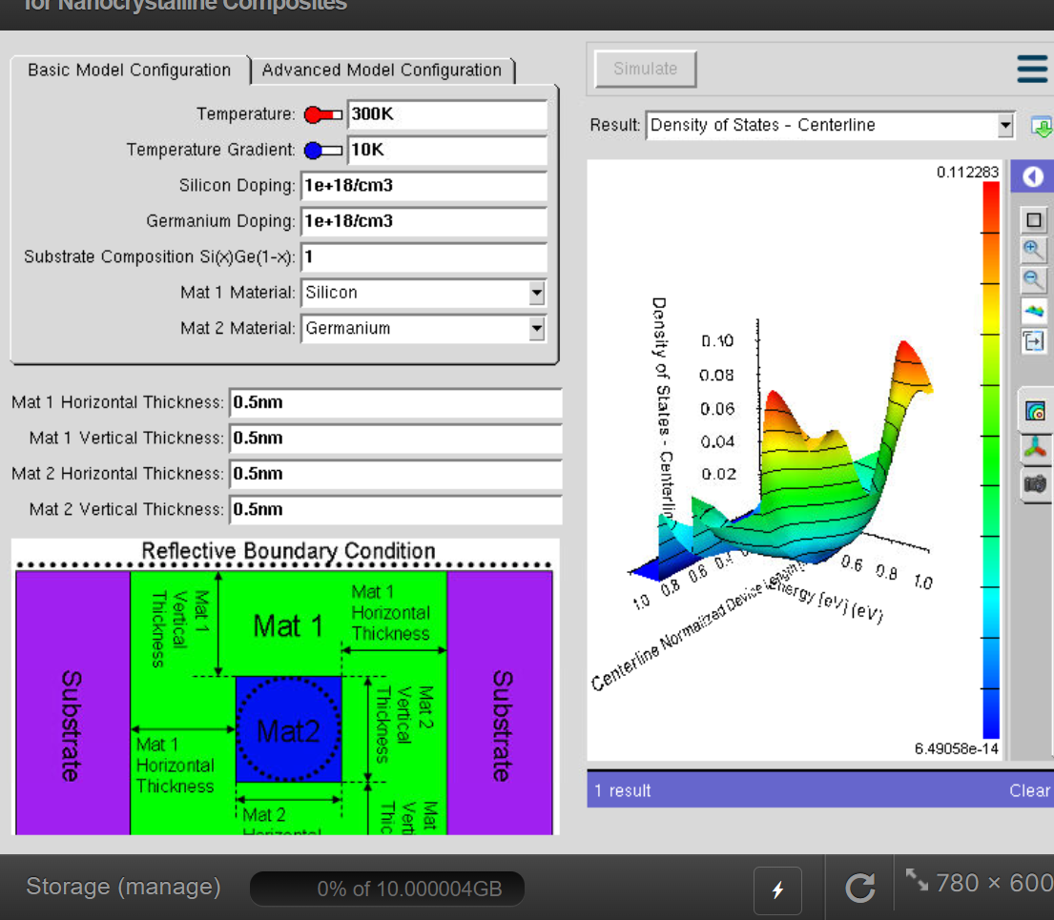
Figure 3. Density of States (DOS) Distribution Along the Centerline of a Si/Ge Nanocrystalline Composite (Thickness = 0.5 nm)
Interpretation (3 Points)
- The DOS plot at 0.5 nm thickness shows distinct energy peaks, indicating the presence of quantized electronic states in the Si/Ge nanocomposite.
- The variation in DOS along the centerline demonstrates that charge carriers are confined within the nanostructure, resulting in non-uniform electronic state distribution.
- The simulation confirms that the 0.5 nm Si/Ge structure provides effective carrier confinement with well-defined energy states, making it suitable for nanoelectronic device applications.

